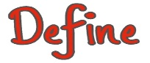  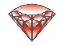  #  7 |     675 |  |  | 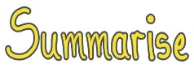  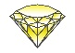 | 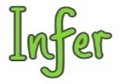  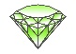 |  | 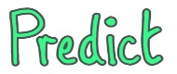  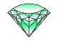 |  |   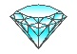 |  | 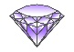  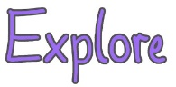 |  | 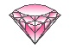  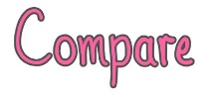
2a: Give/explain the meaning of words in context | 2b: Retrieve and record information/identify key details from fiction and non-fiction. |  |  | 2c: Summarise main ideas from more than one paragraph | 2d: Make inferences from the text/explain and justify inferences with evidence from the text |  | 2e: Predict what might happen from details stated and implied |  | 2f: Identify/explain how information/narrative content is related and contributes to meaning as a whole. |  | 2g: Identify/explain how meaning is enhanced through choice of words and phrases. |  | 2h: Make comparisons within the text
• Explain two things that the words ___, ____ suggest.  • Find and copy a word/two words/a phrase/a sentence that shows _________  • In this sentence __________ is closest in meaning to ________?  • The author uses _________. _________ has two different definitions, use each definition to write a sentence.  • The author uses _________. Why do you think they chose this word?  • The author uses _________. Which of these words could be used to give a similar meaning in the sentence?  • Which word best describe _________?  • Find and copy one word that suggests that ___________  • What does this word/phrase/sentence tell you about ____________?  • Highlight a key phrase or line. By writing a line in this way what effect has the author created?  • Why does the author use ________ repeatedly?  • The writer uses words like _______ to describe ________. What does this tell you ________?  • What other words/phrases could the author have used?  • The writer uses _________to describe ________ How does this make you feel?  • Can you find an example of a word that means ______? | • Identify how ______  • Give two reasons why _______  • True/False  • Fact/Opinion  • Circle the option to complete the sentence.  • When did ________ take place?  • From whose point of view is the story told?  • Which part of the story best describes _______? Explain why.  • Which words and /or phrases __________?  • What evidence do you have to justify your opinion?  • Find the paragraph where _________ |  |  | • What is the main message of the text?  • Number the sentences below to show the order they happened  • Which of these events happened first?  • Which of these events happened last?  • What happened after?  • What happened before?  • What’s the main point in this paragraph?  • Can you sum up what happens in ______?  • Sort the information in these paragraphs.  • Which is the most important point in these paragraphs? How do you know?  • What part of the story do you think is the most important? Explain why you think this. | • Explain how ______?  • Explain why ______?  • Why did _______?  • Why is ________?  • How does ______?  • Why do you think _______? Explain using the text.  • How do you know _______? Explain using the text.  • When do you think________? Explain using the text.  • How can you tell that ______? Explain using the text.  • True/False  • What makes you think that?  • Which words give you the impression that _____?  • How do you feel about ________? Why?  • Can you explain why_______?  • Which word tells you that _____? |  | • What do you think will happen next?  • What do you think would happen if _______?  • Based on what you have read, what does the last paragraph suggest might happen next?  • Can you think of another story, which has a similar theme, e.g. good vs evil? Do you think this story will end in a similar way? Why?  • Why did the author choose this setting? Will that influence how the story develops?  • How is __________ like someone you know? Do you think they will react in the same way?  • What might happen next? Why?  • Choose one character from the book and predict how you think they will behave/react?  • Can you predict several possible outcomes and explain your answer?  • What if…?  • If there was a sequel, what might happen? Why do you think this? |  | • At what point did the characters mood change? Justify your answer using the text.  • What caused the characters to change their actions?  • What caused a change in events?  • Explain why _______  • What is similar/different _______ and ________?  • Why is _______ important in the story?  • Does this story have a moral or a message? Explain how you know using the text.  • Why do you think the author chose to use ________ to present the information?  • How does the _______ encourage you to read on/find information?  • Where does it tell you that _______?  • Why has the writer written/organised the text in this way?  • In what ways do the illustrations support the instructions?  • Who do you think this information is for?  • What atmosphere is the author trying to create? What words/phrases help to create that feeling?  • Why did the author write this story? Find a group of words to show that … has changed.  • What has the author done to make you want to read on? Explain your answer using the text. |  | • What does ________ tell you about ______________?  • What words help the reader to _______?  • What impact does the phrase __________ have on the reader?  •• Highlight a key phrase or line. By writing a line in this way what effect has the author created?  • The writer uses words like ________to describe _______. What does this tell you about ________?  • What other words/phrases could the author have used?  • What technique has the writer used?  • How are these words effective?  • What do you think the writer meant by ‘________’?  • When the author uses this sort of sentence, what is the impact?  • Why did the author ______?  • Why has the author used this word/phrase/sentence?  • How does the author create this mood/atmosphere?  • What is the effect of ________? |  | • How does the characters mood change throughout the text?  • What words would you use to describe the main character at the start and end of the text?  • Compare and contrast different characters, reactions, settings, themes within the text.  • How are the lives of the people different as a result of _______?  • How is it similar to _______?  • How is it different to ________?  • Compare your book to another on the same topic. Which do you prefer and why?  • Would you like to read more books by this author? Explain your reasons.  • If you have read other texts by this author, can you see any similarities/differences between them?
Multiple choice |  | Ranking / ordering | Matching |  |  | Labelling |  | Find and copy |  | Short response |  | Open-ended response

